Preparing QiK drives for use with Propeller Platform controller

HJ Kiela

Oct 2011

**Introduction**

This document describes how to prepare the QiK drives for use with the 4 wheel Omni platform

**Installation**

Step 1 Connect all drives to the schematics to

Step 2 Open the program QiK SetParameter1.spin in the spin editor

Step 3 Connect the propeller board via USB to the PC and power the board and drives.

Note: Leave only the serial connection for the drive for Right Front connected. The others must be released for now.

Step 4 Press F7 to locate the serial port for the propeller. Open the Propeller terminal and set com port accordingly/

Step 5 Load the SetParameter1.spin program via F10. And enable the terminal. The terminal should show something like:

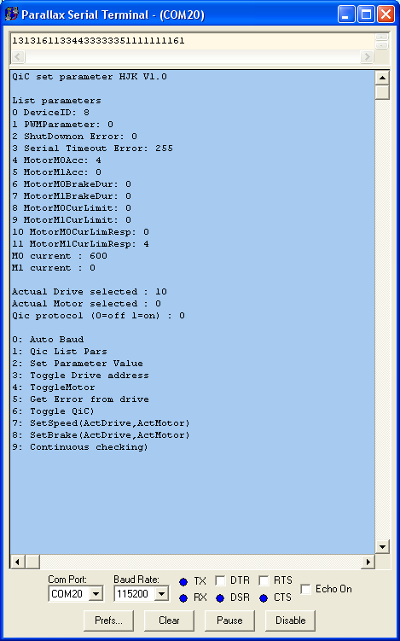

Step 6 Press 1 (List parameters)

Now the screen should look like

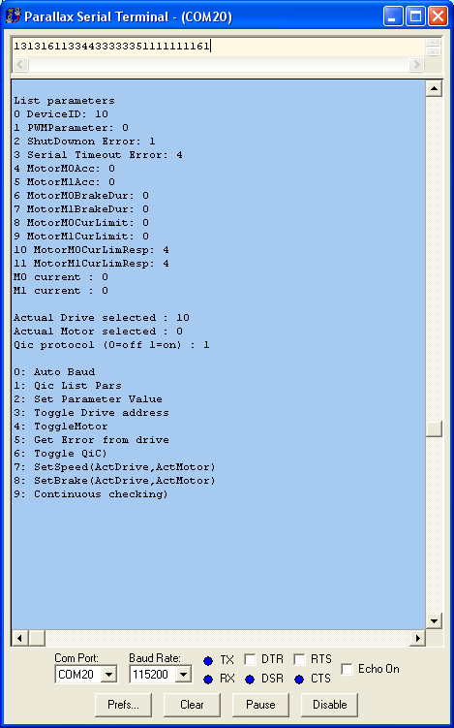

Step 7 Set the parameters in drive 10 according to the screen above.

Note that parameter 2, 3, 10, 11 are set right

Step 8: Write address #10 on the drive with a marker pen.

Step 9 Set drive #11 to #13.

Disconnect Right Front drive #10 and connect drive Left Front. This one should get address #11, but still has #10. Therefore do following:

* Disable QiK protocol (6)
* Set device ID to 11 (and save)
* List Parameters (1) to see if the address indeed was changed.
* Now set the other parameters as with drive #10

If all is OK, disconnect the drive and move on to the next ones:

Drive #12 is the one Rear right

Drive #13 is the one Rear Left

Step 10:

Connect all drives and test with QiC protocol enabled, if you can list parameters (1) from individual drives after selecting the next one (3)